Court

Attire, Courtroom Conduct, and Children
- Unless I have told you that you will be a live witness, you generally do not need to accompany me to court. I am there on your behalf and court may be adjourned. However, I generally recommend that you do accompany me, as it shows that you’re serious about the matter, there is often last-minute negotiation before or during court, and the Court may require information from you or want to know if you would be agreeable to a particular arrangement. It doesn’t hurt for family members to accompany you to show support, but isn’t necessary.
- I recommend that you arrive at the Courthouse at least half an hour in advance.
- Hats are generally prohibited in court, and chewing gum should be thrown out.
- I recommend wearing business casual attire, and avoiding jeans and t-shirts. Piercings should be removed if possible, and tattoos covered.
- It is very unlikely that you will need to speak in court. Many judges will not allow you to speak to them directly, and you will not be able to speak to me while I am speaking to the judge.
- The chairs in the front row are reserved for lawyers. Please remain seated when our matter is called. You may only accompany me to the front with the permission of the judge.
- If any family members or friends accompany you, please tell them not to speak to the judge unless they have been asked to do so by the judge.
- Please avoid bringing any of your children to court unless you have been asked to do so.

Morning Chambers and Docket
- Most application are “interim”, essentially meaning temporary, until the matter can be settled or resolved at a trial. They are primarily used to ask the Court for urgent orders, or to set the procedure to be used to resolve your matter. Examples include ordering the exchange of financial information, setting interim child or spousal support, confirming the status quo for parenting arrangements, safeguarding children or property which are at clear risk of imminent harm, ordering the sale of land, appointing an independent lawyer for children, appointing a psychologist to perform an assessment, deciding who can reside in a home until your matter is resolved, deciding whether the next step is Special Chambers or a trial, and so on.
- Applications are ordinarily first heard in morning chambers (Court of Queen’s Bench) or docket (Provincial Court).
- Here, each side will only have a few minutes to speak, and it is unlikely that the judge will have read any of our documents. The judge might be unlikely to grant an order unless it is urgent or obvious. It is very fast-paced, with many other matters waiting to be heard. Adjournments are common, especially if the other side is still trying to find a lawyer or needs more time to assemble their documents or affidavit/statement.
- On rare occasions we might ask you for additional information, whether you’d accept an arrangement, or our judge may ask you to acknowledge their advice, but otherwise, you will generally not be expected or asked to speak.
- If there is an application to add a guardian in Provincial Court, the Court may require the proposed guardian to take the stand to confirm that they are suitable to become a guardian, and understand the responsibilities of becoming a guardian.
- Court is often a very slow, time-consuming, and frustrating process, which is why I generally strongly encourage negotiated resolutions.

Trial
- If the filed materials (affidavits or statements) disagree about important facts that could significantly affect the decision, and there is not a lot of information to corroborate either version of events, then disputes are often directed to go a trial or oral hearing, so that the judge can hear each person and assess their credibility, or potentially listen to third parties.
- In the Court of Queen’s Bench, trials are often over a year away, and require many steps to occur before a date can be set. Often each spouse, new partners, extended family members, psychologists or other experts who have prepared reports, teachers, childcare workers, doctors, dentists, and other similar witnesses may testify. I have had judges direct 3 week trials.
- Oral hearings in the Provincial Court are sometimes closer to 6 months away, however the Provincial Court is limited to resolving only certain issues, for example it cannot grant divorces or resolve many property disputes.
- Given the delay, expense, and frustration of trial, it is rare that disputes go all the way to trial, often they are resolved before that time.
- If your matter proceeds to trial, we will discuss trial further.

Special Chambers, Summary trials, and Family Resolution Hearings
- If there is not too much disagreement about the relevant facts, we can set a matter for Special Chambers (Court of Queen’s Bench), a Family Resolution Hearing (Edmonton Provincial Court), or a Summary Trial (Court of Queen’s Bench, most useful to settle disputes involving property to avoid a regular trial, but can also be helpful in other scenarios).
- These decisions are based on the filed Affidavits or Statements, and there are usually no live witnesses. It is very unlikely that you will be expected or requested to speak.
- If there is disagreement about only a limited number of facts, we can ask for permission in advance to have live witnesses testify on only those facts, which might decrease the likelihood of the Court determining that it cannot make a decision and we instead must have a trial.
- To narrow the amount of disagreement on relevant facts, we can conduct a “Questioning”, to have each side answer questions, clarify their answers or provide further documentation. Questioning is usually done in a law office boardroom, with someone present to type each question an answer.
- At Special Chambers or a Family Resolution Hearing, our judge will typically have read the filed documents, and might have read the transcripts (although portions of the transcript can still be read into court, especially if either side admits that they lied). At Special Chambers, our judge will have also read our Brief (Confirming Letter), which briefly sets out our position and legal arguments.
- We are generally given only one-hour for Special Chambers and Family Resolution Hearings, however we can request permission for longer periods, such as a half or full day. This might affect how quickly we can obtain a date though.
- Special Chambers and Family Resolution Hearings are generally scheduled roughly half a year away, or sometimes sooner, depending on the time of year.

Decision
- Once a judge makes a decision, that decision generally takes effect immediately, even if a written order isn’t drafted yet. The major exception is that if a person doesn’t appear, they need to be served with the order before they can be found to have breached it.
- Judges are human and sometimes make mistakes, or sometimes they are deciding on a unique area of the law that isn’t clear. Appealing a decision may be possible, but has varying degrees of difficulty depending on the type of decision. If you are interested in appealing, we should discuss this further. Appeal Notices must usually be filed within 30 days or one month of the decision, depending on the type of decision, meaning that we should decide whether or not to appeal well before this date.
- The judge may also order that one side pay “costs” to the more successful side. Although in theory this is meant to reimburse for legal costs, cost amounts are usually calculated in reference to a table in the Rules of Court, and are more akin to penalties than a full reimbursement, except in the case of egregious misconduct. In many family law matters no costs are awarded, as orders are complex enough that both sides often enjoy mixed success. Costs are also rarely awarded against people who have no income or liquid assets. My practice is to not request costs if I am of the opinion that no judge would grant them.

Alternative Dispute Resolution
- The aim of the following out-of-court processes is generally to arrive at a resolution that each spouse can live with, faster, at a lower cost, and often attempting to preserve relationships. If you are interested in any of these, please speak to me.
- Four-way meetings are meetings where each spouse and both lawyers meet in the same room to cooperatively discuss the dispute, rather than miscommunicating or attacking each other through dozens of letters or court.
- Collaborative Law is designed as a series of four-way meetings outside of court. This formal process is for those who desire generally the lowest-stress and most-cooperative method to resolve disputes, without the constant threat of legal action.
- Mediation is when an independent person is in the room, who provides information, ideas, and pressures each side into being reasonable. This can be with or without lawyers, and there is a very broad selection of mediators from lawyers to psychologists. Parenting and support mediation through Family Justice Services at the Court of Queen’s Bench is free if either side earns less than approximately $40,000.00 per year.
- Arbitration is where an independent party who is not a judge can make a decision which each side agrees to follow. There is also Med-Arb, where the mediator becomes an arbitrator and makes a decision if the mediation is not successful.
- Parenting Coordination is essentially a series mediation meetings using a psychologist, usually either to come up with a parenting plan or to address ongoing conflict. This is a useful method to resolve parenting disputes, as many judges often follow the psychologist’s recommendation anyways. There is also Parenting Coordination with Arbitration, where the psychologist becomes an arbitrator if Parenting Coordination is not successful.
- Judicial Dispute Resolution (JDR) is essentially mediation using a judge, at no additional cost. Everyone will be likely to take the judge and their interpretation of the law seriously. Binding JDR is also available, in which the judge makes a decision if we’re unable to come to an agreement. JDR is generally available through all courts.
- Psychologists, Appraisers, and Accountants can also help to resolve disputes.

Location
- This is the map of Edmonton Courthouse, including entrances and common parking locations. The open-air lots to the East usually have available spaces and are a lower cost. The Canada Place parkade to the south is one of the lower cost underground parkades with pedway access to the Courthouse. The parkade underneath City Hall (accessible on the East side) is underground and the shortest pedway walk to the Courthouse, although it can be expensive for full-day appearances. The parkade to the south of the Courthouse is very expensive.
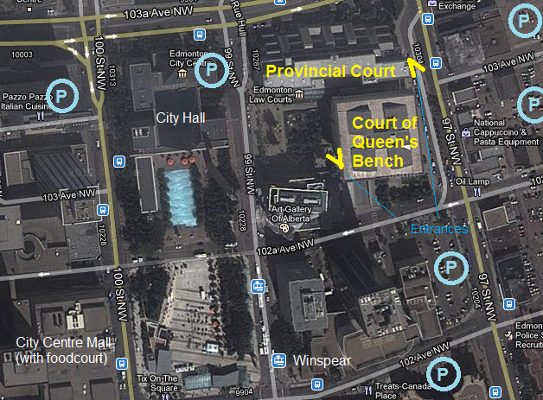
- I suggest putting at least three hours in the meter for morning/afternoon chambers or docket, although on the rare occasion more time may be needed.
- At the Edmonton courthouse, the North side of the building is the Provincial Court, and the South side houses the Court of Queen’s Bench and Court of Appeal.
- Once you get to the correct side of the building, there will be electronic screens and individual search consoles to help you find our room number. The first digit of the room number corresponds to the floor number.

